Digital Nurture 5.0 - Java FSE React

Week 1 - Module 1: Design Patterns and Principles
Name: Sarthak Kumar
Email: rphoenix432@gmail.com

Exercise 2: Implementing the Factory Method Pattern

1. Objective
The objective of this exercise is to implement the Factory Method Design Pattern in Java.
This pattern is used to create objects without directly exposing the object creation logic to the client.
In this exercise, different types of documents such as Word Document, PDF Document, and Excel Document are created using separate factory classes.

2. Scenario
A document management system needs to create different types of documents. The system should be able to create Word, PDF, and Excel documents.
Instead of creating these document objects directly inside the main class, the Factory Method Pattern is used. This helps in separating the object creation logic from the main application logic.

3. Project Details
Project Name: FactoryMethodPatternExample
Programming Language: Java
Design Pattern Used: Factory Method Pattern
Week: Week 1
Module: Module 1 - Design Patterns and Principles

4. Project Structure
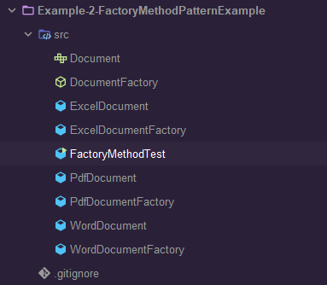

5. Document.java


6. WordDocument.java
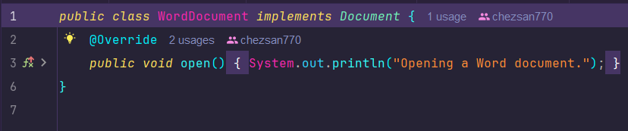

7. PdfDocument.java
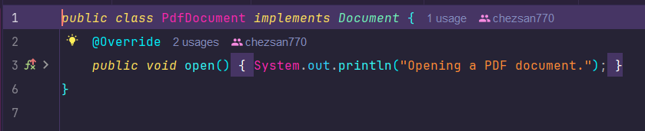

8. ExcelDocument.java
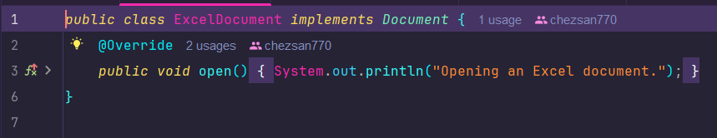

9. DocumentFactory.java


10. WordDocumentFactory.java
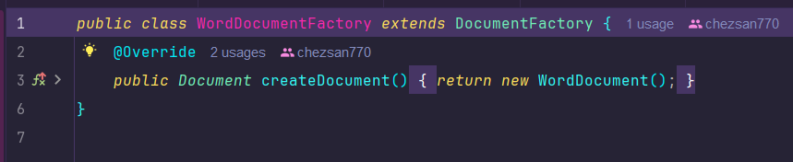

11. PdfDocumentFactory.java
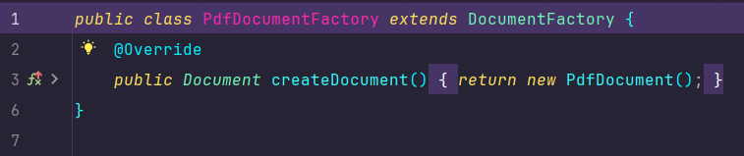

12. ExcelDocumentFactory.java
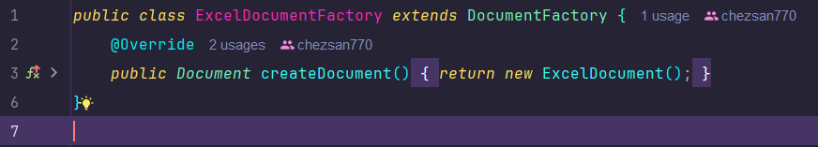

13. FactoryMethodPatternTest.java
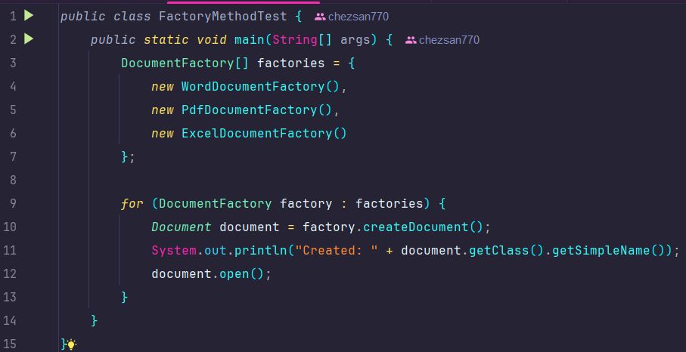

14. Output
